legends: Orange (Medium Priority), Red (Critical/High Priority), Blue (Info), Green (Good work!)

Done, Important

# Monday, 05 August 2024

OK just realised that to show the hypothesis that the results might just be coincidence due to octave band energy curve and not accurate, I should’ve had the energy curve saved as well. So let’s save those as well into a folder named ResultsV1 in Atiyed-Matlab folder. Also, to make it easier to compare with the Kim21, let’s follow the order its using as well. Added lines in matlab script to compared the RT60 in octave bands as well as created separated script for each scene results (less commenting/uncommenting)

## MR result v1

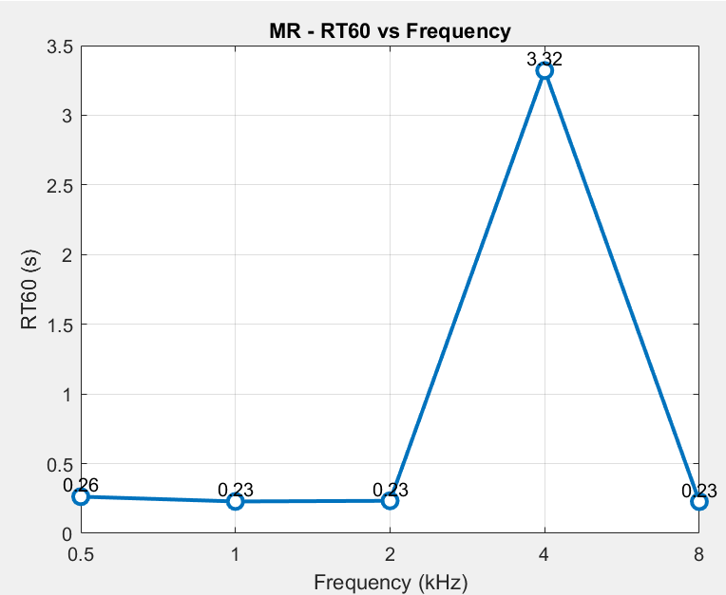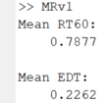

Uses RT42.5

0.5 volume , physics based attenuation, 1:1 direct to reflections mix

## KT result v1

Uses RT60

0.01 volume level, physics based attenuation, 1:1 direct to reflections mix

## LR result v1

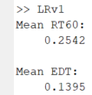

Uses RT30, decay_range value in irStats.m divided by 2 for EDT.

0.01 volume level, physics based attenuation, 1:1 direct to reflections mix

## ST result v1

## BIG FINDINGS/CHANGES



Reverted back irStats.m to usual, because im stupid and don’t understand code properly, it supposed to be 60 because that is the scaling/extrapolation, its already done… this also makes it easier to trial and error y_fit as only need to change 1 line instead.

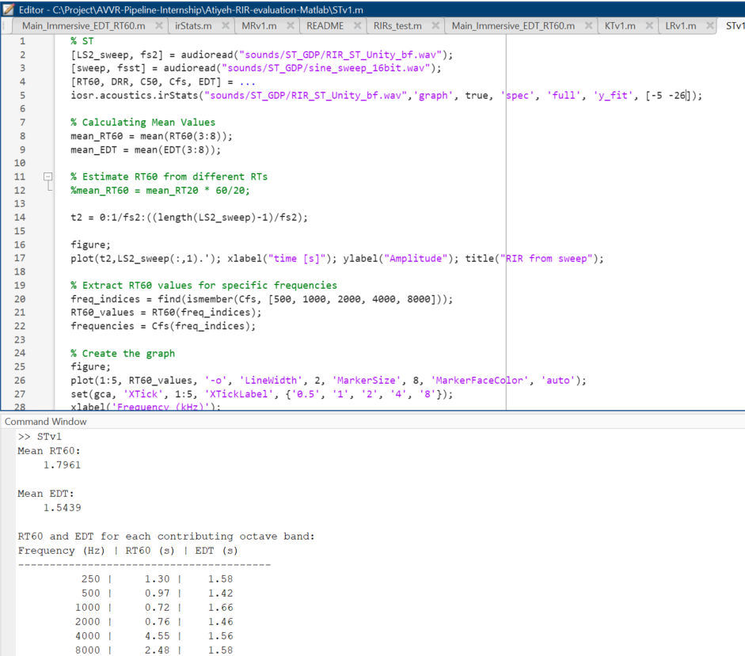Also added the table to see RT60 and EDT for each bands more clearly..

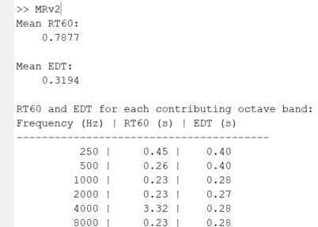Lets redo everything!

## MR result v2

Uses y_fit = 42.5 / RT42.5  
0.5 volume , physics based attenuation, 1:1 direct to reflections mix

## KT result v2

Uses RT60  
0.01 volume level, physics based attenuation, 1:1 direct to reflections mix

## LR result v2

Uses RT30, as we no longer modify irStats.m, the EDT is very wrong.

* 1. volume level, physics based attenuation, 1:1 direct to reflections mix
  2. and EDT cant be fixed by reducing volume either as it is in lowest volume…

## ST result v2

Uses y_fit = 26 / RT26 …. Idk man.

0.5 volume level, physics based attenuation, 0.5:5 direct to reflection mix.

## UL result v2

Uses y_fit = 36 / RT36 …

0.5 volume level, physics based attenuation, 1:1 direct to reflection mix.

As seen from all above graphs, this is obviously not correct as its not slightly balanced at all on all octave bands compared to Kim21 result [28VR.pdf (3dkim.com)](http://www.3dkim.com/Eng/papers/28VR.pdf)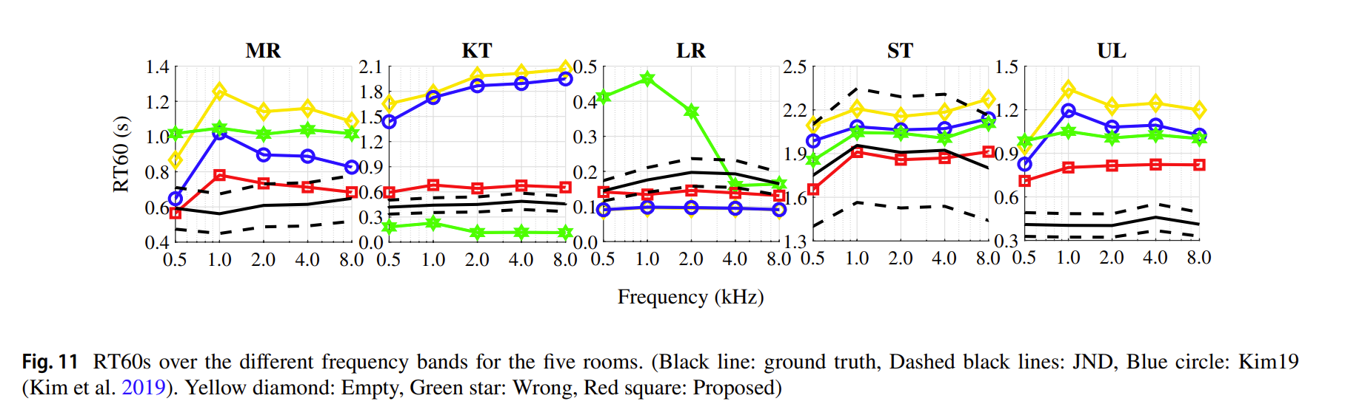

Interestingly enough, latest 2022 paper ([29EUSIPCO.pdf (3dkim.com)](http://www.3dkim.com/Eng/papers/29EUSIPCO.pdf)) doesn’t have the graph for each octave band in the paper which makes it more suspect…

This problem also is not isolated to only my mesh/result but Mona’s latest audio that I have as seen below.

## Mona’s ST

Ignore the MR title on graph..

## Mona’s MR

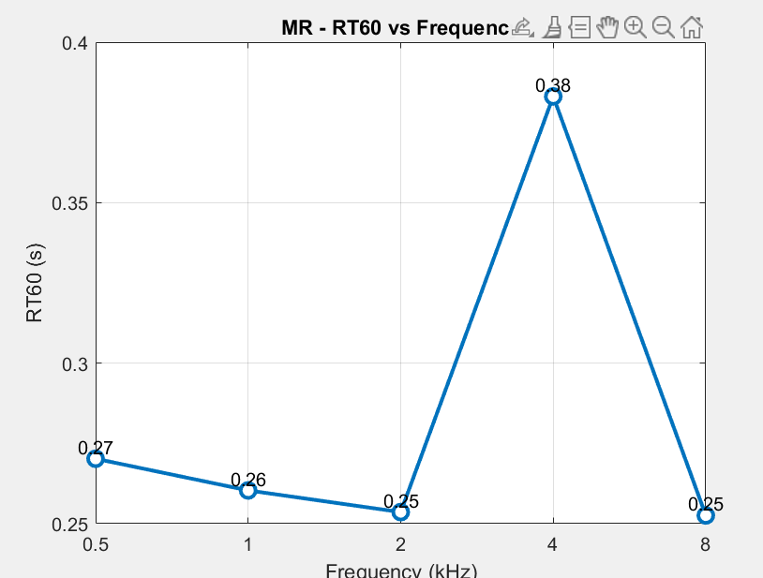As seen from ST and MR, this doesn’t look right…

## Mona’s KT

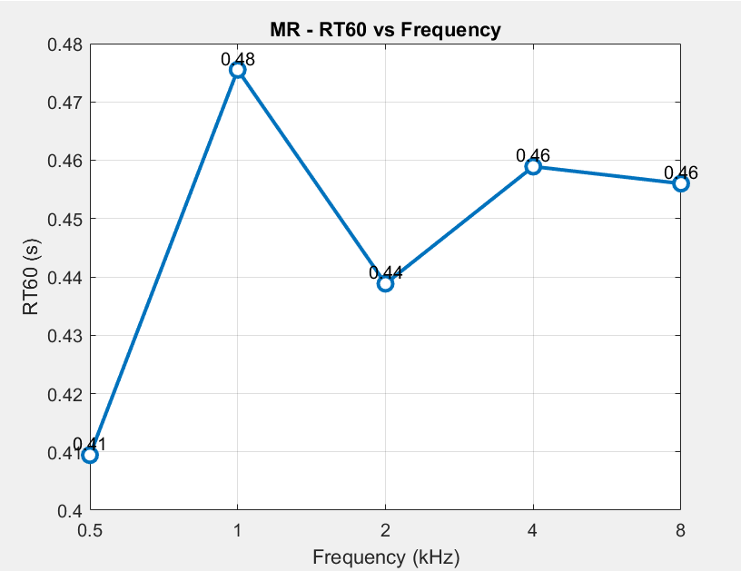Interestingly though, it looks pretty right for KT for some reason.

## Mona’s UL

## Verdict:

Theory right now is either a limitation in the way audio is recorded or the audio source itself (sine sweep), as in S3A, it seems evaluation scene uses sine ‘sweep-repeat’ instead, but I have no idea how to deconvolve or the correct way to record it because it is looping as well…